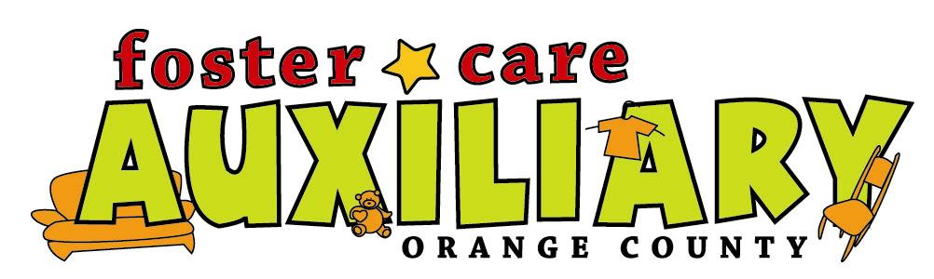
Support Group
at the
Foster Care Auxiliary
333 S. Brookhurst in Anaheim
(between Orange and Broadway)

Join us for training, support, and networking

9am-11am

Facilitator: Kathy Harvey
Future dates in 2008:
October 6
November 3
(Mostly 1st Mondays of the month)

For information or to register:
Call 714 778-3383 or email FosterCareAux@yahoo.com
Past Topics:
July-Opposition Defiant Disorder
August-Lying
September-Fire-Setting
Rough draft of Future Topics:
October-Running Away
November-What to do in the initial stages of an allegation and why you should not be afraid.
December-No Meeting
January-Licensed Foster Parent Resources; Mileage/Child Care Reimbursement, Foster Parent Liaison & Support Workers are there for you to utilize!
February-Childcare Recording Information System (C.R.I.S.); software and training
March-Arts for Healing
April-Healthy Smiles for Healthy Kids
May-Life Books
June-Gang Prevention
July-Wetting and Soiling
August-Black Hair Cair
September-No Meeting
October-Eating Disorder
November-Sleep Problem
December-No Meeting

